LCD screen annotation  
Menu Item Function Description

Prepare:

Disable steppers

After clicking, the motor can rotate freely, generally used as a zero return, manually sliding the nozzle to level.

Auto-home

The nozzle returns to the origin of coordinates

Pre-heat PLA

Appropriate print temperature for heating nozzle and hot bed to PLA material

Pre-heat ABS

Appropriate print temperature for heating nozzle and hot bed to ABS material

Change filament

load

upload

**Cool down**

Be able to cool the nozzles and hot beds

Move X

Move Y

Move 10mm

Knob to adjust the amount of movement

Move E

Move Z

Move 1mm

Move 0.1mm

Moving axis

(Unit movement amount When 10mm is selected, only XY can be moved, select the movement axis, where E axis is the extrusion motor, and it can only rotate when the nozzle temperature higher than 180)

Control：

Temperature Only the common options (nozzle, hot bed, fan speed) are listed, the knob rotation determines

Reset Can be used when there is an abnormality

Refresh Refresh and display

memory card

*.gcode select the file

一、 turn on the power supply, the main interface of the screen after turning on the machine

Nozzle temperature（Upper: Target temperature Below: current temperature） hot bed temperature

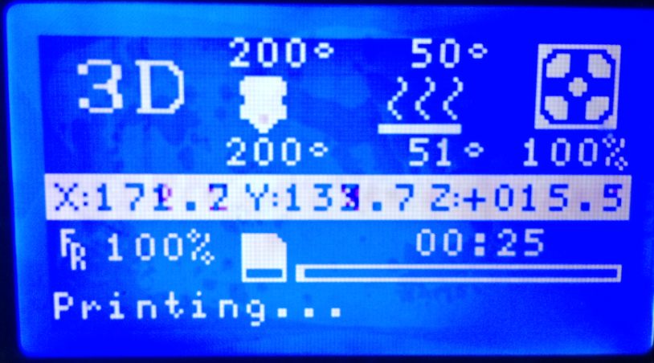

Fan speed

Printing speed

Print time and progress

Press the knob to enter the main menu interface

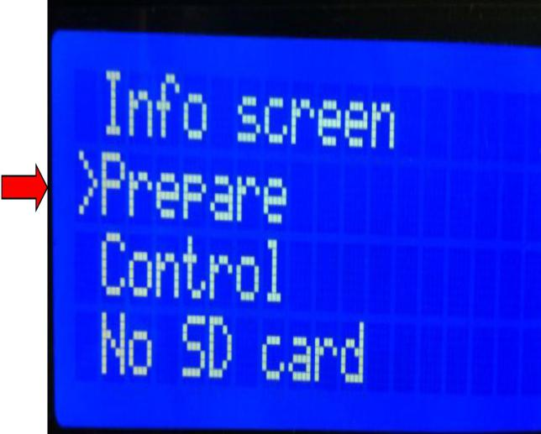

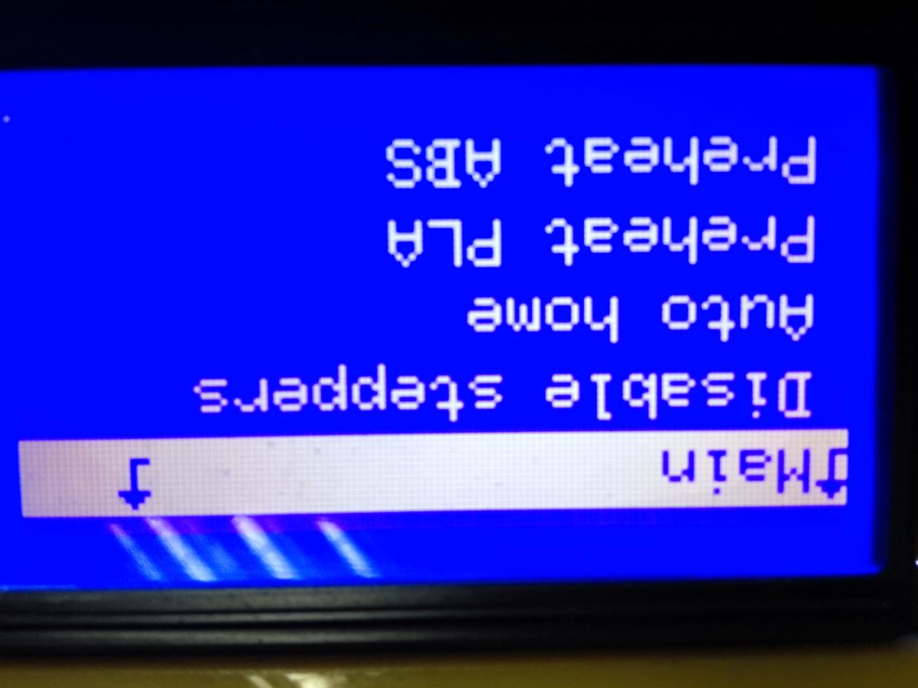“↑” means you can return. “→” means you can continue to execute. Currently, there is no SD card status.

**preparing interface**

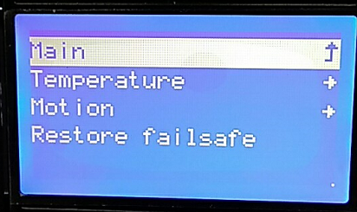

c

**control interface**

**二、 Main menu interface during printing**

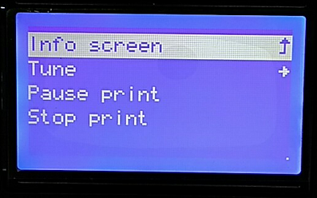

The "Control" option is the same as the above; "Pause Print" implements a print pause, the printer will stop printing after clicking, the original option becomes "Continue Print" option, click to continue printing; the "Stop Print" option can make the printer stop print.  
"Adjust" Click to enter the following interface (according to the actual interface of the machine).

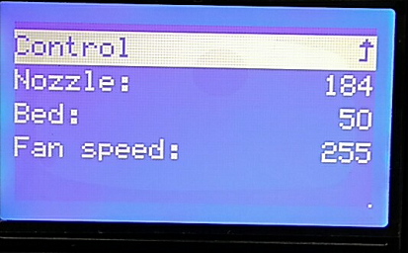

Print rate (percent, 100 is 1)

Nozzle temperature adjustment

Hot bed temperature adjustment

Fan speed adjustment (range: 0~255)

Filament output (percent, 100 is 1)

Replace supplies in printing

Method 1: Cut out the end of the consumables, use the old consumables to feed in the original consumables, and straighten the consumables to ensure that the extrusion gear can send the new consumables.

Method 2: "Pause printing" first, and then select “upload” of the “feeding” in the "Preparation",. Quickly pull out the consumables after the filament had already uploaded. Then select “feeding” after loading the filament, clean the consumables that come out from the nozzle, and select “ continue print”